

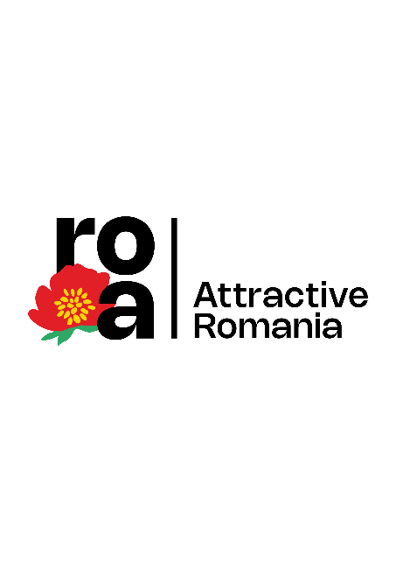

**Discover the hidden treasures of Eastern Europe through the "Attractive Romania" cultural tourism program**

* *Choose sustainable tourism, plan and customize your next cultural trip to Romania, through the Attractive Romania app.*
* *Unknown magical castles: 21 historical sites that rival the famous Bran, Dracula's refuge.*
* *The Danube and Dacia province Limes are part of the most complex and longest border section of the Roman Empire on the continental European territory.*
* *Discover the specifics of Romanian villages, which have charmed even King Charles.*

**Bucharest, June 2024 – The search for the upcoming authentic experience, preparing and researching for the next European cultural tourist destination has become much easier through the "**[**Attractive Romania**](https://romania-atractiva.ro/)**" cultural tourism program.**

Why cultural tourism in Romania? Because many things are said about this country rich in history, culture and natural landscapes: that it is the country with the largest virgin forests in Europe, the place where there is still consistent wildlife, including large predators (bears, wolves, lynxes), villages and traditional households seemingly straight out of the Middle Ages, still inhabited medieval fortresses, scenic traditions, painted churches, stories and legends, welcoming people, but also some bad roads or inappropriate touristic real estate developments.

Imagine stepping into a world where history whispers through ancient walls, where vibrant traditions come to life in charming villages, and where breathtaking landscapes captivate your soul. This is exactly why it is not easy to choose when you come to Romania, a hidden gem of Eastern Europe. Maybe you have heard of the Bran Castle, about Mamaia – the fun filled sea-side resort, the Carpathian Mountains, or the Palace of Parliament, but these are just the tip of the iceberg when you ask yourself, ***"What do I want to see and what do I want to experience when traveling to Romania?***"

What you already knew about Romania is interesting, even exciting, but the answer lies in the "Attractive Romania" program, the innovative program that offers an interactive platform for exploring the country's most fascinating tourist attractions. Just like the well-known tourism programs in Greece or Italy do. So, download the Attractive Romania app, play with it, experience what it can provide and create your own route. Do you want to see monasteries or castles? Do you want to eat unique dishes? Are you passionate about ancient history? Want to fill your Instagram account with photos of fairytale villages? With this new cultural and historical tourism program you have everything. Oh, and you don't need to learn Romanian for that, as the app is available both in Romanian and [English](https://play.google.com/store/apps/details?id=net.mipe.android.romania_atractiva&pli=1)!

**Following the knights’ footsteps: 21 castles to rival the famous Bran Castle, Dracula's refuge**

Medieval fortresses and castles stand proud in Romania, folklore and legends are woven into everyday life, and untouched natural beauty awaits explorers. Surely most people have heard of the Bran Castle, the famous refuge of Dracula. But did you know that Romania has at least 21 castles that rival Bran in terms of history and architecture? You can find them directly in the "Attractive Romania" app. This way you may discover many other places that are related to the voivode Vlad Țepeș - Dracula, such as Târgoviște, Sighișoara or Poienari Castle, the fortress of refuge for the Wallachian voivodes at the beginning of the Middle Ages.

Starting with mysterious ruins, to fortifications that have been transformed and restored over hundreds of years, every wall tells us about a lesser-known European history, intertwined with stories and legends. The place where we learn the secrets of the nobility and discover chapters of history full of glorious deeds and towering figures, but also dark times of torture and betrayal.

If you are interested in castles like Bran, all of them are brought together in one of the 12 predefined routes of the program, in the [Castles Route](https://romania-atractiva.ro/en/routes/castles-route), through which travellers learn about lesser-known treasures, such as the [Sturdza castle in Miclaușeni](https://romania-atractiva.ro/en/profiles/castelul-sturdza), a historical monument of Gothic art, erected between 1880 – 1904, which housed at one point the Miclăuşean Library, a private collection made up of approximately 60,000 volumes. The book collection of the Sturdza family included both Romanian books (mostly the princeps editions of the 18th and 19th centuries, copies of almost all Romanian chronicles, as well as prints or religious manuscripts from the 16th-19th centuries), as well as foreign (numerous princeps editions from European literature, philosophical writings from antiquity and the Middle Ages, historical works or with moral and religious content, as well as magazine collections).

Equally interesting is the [medieval Huniade Castle](https://romania-atractiva.ro/en/profiles/castelul-huniade), linked to its founder, the King of Hungary, Carol Robert of Anjou, who lived in Timișoara for a short time, between 1315 and 1323; or the [Ghica Mansion](https://romania-atractiva.ro/en/profiles/conacul-ion-ghica), an important landmark in Romanian culture and the history of Romanian literature, which is marked by the personality of the great politician Ion Ghica, the one who helped the Ottoman Empire eliminate piracy from the Greek island of Samos.

"Attractive Romania" thus offers an immersive experience in the heart of the Romanian heritage, presenting 12 thematic routes with over 275 objectives, each with its own unique story.

**2000 years of tradition and transformation: Between the Roman conquest and ancient villages, forever set in history**

The "Attractive Romania" program highlights Romania's cultural wealth. The Wooden Churches Route and Moldovan Monasteries Route reveal the country's spiritual heritage through stunning religious architecture and sacred art, while the [Roman Castra Route](https://romania-atractiva.ro/en/routes/route-of-the-roman-castra) connects travellers to the ancient past, highlighting Romania's role within the Roman Empire through sites such as Ulpia Traiana Sarmizegetusa, the temporary capital of Dacia after the Roman conquest.

From Ulpia Traiana Sarmizegetusa, to the ruins of the Romano-Byzantine Fortress Sucidava, the 1,500-kilometer road, along the Dacian salt and gold roads, presents us with the most complex defence systems of the ancient world. In fact, the Danube and Dacia province Limes is part of the most complex and longest border section of the Roman Empire on the continental Europe territory.

We continue the story of ancient treasures with the most important hoard of gold and precious stones ever discovered in Europe, the famous treasure called “The hen with the golden chickens”, found in 1837 in the vicinity of the [Roman Castrum in Pietroasele](https://romania-atractiva.ro/en/profiles/castrul-roman-de-la-pietroasele). Until 1922, when Tutankhamun's tomb was discovered, the Pietroasa Treasury was the largest in the world. Further on the gold theme we arrive at [Roșia Montană](https://romania-atractiva.ro/en/profiles/gospodarii-traditionale-in-localitatea-rosia-montana), the epicentre of gold mining in the Dacia province, where the architecture was shaped by the mining activity and adapted over time, its stone and wooden houses representing a window towards the local cultural heritage. An example of architectural mastery, just like the village of [Saschiz](https://romania-atractiva.ro/en/profiles/gospodarii-traditionale-in-localitatea-saschiz), one of the villages that stole the heart of even King Charles.

**Choose the sustainable option: cultural tourism with Attractive Romania**

Through the Attractive Romania cultural tourism app tourists may explore various cultural attractions, castles, old churches or archaeological sites, but they can also discover other aspects of the Romanian culture, such as traditional gastronomy or the production of local wines and beverages.

The app provides detailed information about each attraction so visitors can make informed decisions about the places they want to visit and avoid tourist traps. They can also discover themed itineraries or build their own tourist routes, tailored to their specific interests.

Through Attractive Romania, cultural tourism becomes more than a simple visit to some touristic objectives; it becomes an authentic and interactive experience that allows the visitor to explore and better understand the culture and traditions of a region and of the entire country. And in the end, the tourist leaves not only with some great Instagram photos, but with a personal and cultural experience, while the local community manages to be sustainable and replicate this experience for other tourists, without being altered by the negative effects of fast-tourism.

**Press contact:** Andrei Stanca, tel. 0742.084.770, email: andrei.stanca@zagabrand.ro

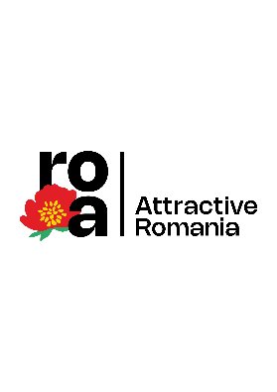

[www.romania-atractiva.ro](http://www.romania-atractiva.ro)

**NRRP: Funds for a modern and reformed Romania!**

ABOUT ATTRACTIVE ROMANIA. The Attractive Romania Program, with a value of 36.356.328,86 lei, is part of Component 11 - Tourism and Culture, Investment 1 - Promotion of the 12 tourist/cultural routes, Pillar 332 of the National Recovery and Resilience Plan (NRRP). The programme, coordinated by the Ministry of Investments and European Projects, has 211 direct beneficiaries (custodians of the cultural objectives to be visited) and the main beneficiaries of the programme are, starting today, the Romanian and foreign tourists.

Attractive Romania is the national cultural tourism program. The program offers tourists from both Romania and abroad a travel experience where, alongside spectacular castles, manor houses or monasteries, they will discover authentic food, cultural experiences, fortresses, ruins, walls or foundations of architectural or archaeological sites that bring together elements of multiculturalism unique in Europe.